**New Islington Medical Practice - 0161 272 5660**

**06/07/17**

**NEED**

**SOMEONE TO**

**TALK**

**TO?**

**Find overleaf a range of services that are more than happy to help.**

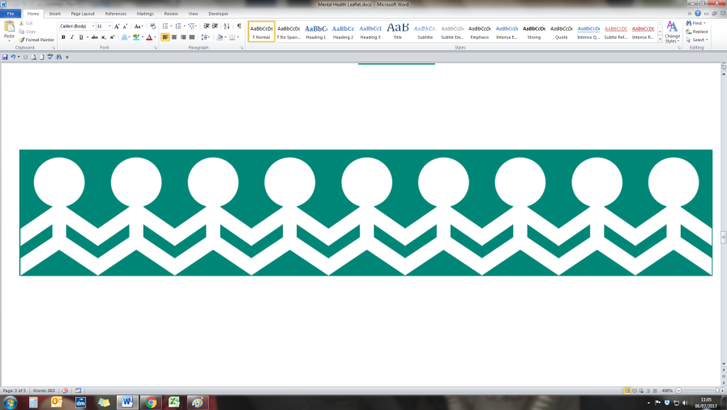

**If you are a child or young person, and need some help, call:**

* **42nd Street – 0161 228 1888**
* **Emerge 16/17 Community Mental Health – 0161 226 7457**
* **YASP – 0161 221 3054**
* **NSPCC – 0800 1111 *(Childline)*, 0808 800 5000 *(Adults)***
* **Kooth – 0161 877 7746**

**If you would like to discuss issues related to parenting, relationships or bereavement (in that order), call:**

* **Family Lives – 0808 800 2222**
* **Relate – 0300 100 1234**
* **Cruse Bereavement Care – 0844 477 9400**

**If you are an older person and feel that you need support, call:**

* **Age UK Manchester – 0161 833 3944**

**If you are a carer and require support, call:**

* **Manchester Carers Forum – 0161 819 2226**



**If you feel more comfortable talking to someone of your own ethnicity/religion, you can call:**

* **Irish Community Care – 0161 205 9105**
* **African & Caribbean Mental Health Service – 0161 226 9562**
* **The Wai Yin-Kwan Wai *(Chinese/Vietnamese)* – 0161 833 0377**
* **Chinese Mental Health Association – 0845 1228 660**
* **CIO Indian Mental Health – 0161 795 0135**
* **Rethink - Asian Mental Health Helpline – 0808 800 2073**
* **Crossline *(Christian)* – 0300 111 0101**
* **Muslim Community Helpline – 0208 904 8193/0208 908 6715**
* **Jewish Helpline – 0800 652 9249**

***“Mental health… is not a destination but a process. It’s about how you drive, not where you’re going.”***

**Noam Shpancer, The Good Psychologist: A Novel**



**For alcohol/drug related problems, call:**

* **Alcoholics Anonymous – 0845 769 7555**
* **MIDAS - 0161 214 0770**
* **Narcotics – 0300 999 1212**
* **FRANK *(multilingual)* – 0800 77 66 00**

**If you need help about a gambling problem, call:**

* **GamCare – 0808 8020 133**

**If you are a victim of crime or affected by domestic violence and need support, call:**

* **Rape Crisis – 0808 802 9999**
* **Victim Support – 0808 168 9111**
* **Refuge – 0808 2000 247**
* **Manchester Women’s Aid – 0161 660 7999**
* **Men’s Advice Line – 0808 801 0327**
* **Respect *(perpetrator)* – 0808 802 4040**

**For gender/sexuality-specific support, call:**

* **Men's Health Forum – 020 7922 7908**
* **CALM (Campaign Against Living Miserably) – 0800 585858**
* **Neesa Well Women – 0161 740 2995**
* **The LGBT Foundation – 0845 3303030**



**For less urgent support, you could call:**

* **Manchester Mind – 0161 226 9907**
* **Self Help Services – 0161 226 3871**
* **The Roby – 0161 257 2653**
* **Mental Health Foundation – 020 7803 1100**
* **Mind – 0300 123 3393**

**For support about a particular mental problem, call:**

* **Rethink Mental Illness – 0300 5000 927**
* **Anxiety UK – 08444 775 774**
* **No Panic – 0844 967 4848**
* **Mood Swings – 0161 832 3736**
* **Bipolar UK – 0333 323 3880**
* **Hearing Voices Network – 07714 93 0740**
* **Post-Natal Illness – 020 7386 0868**
* **OCD Action – 0845 390 62 32**
* **B-eat *(eating disorders)* – 0808 801 0677 (Adults), 0808 801 0711 *(under 18)***
* **Mencap *(learning disabilities)* – 0808 808 1111**



**If you are going through a crisis and are in need of immediate support, call:**

* **The Manchester Mental Health Crisis Line – 0161 922 3801**
* **The Sanctuary – 0161 637 0808**
* **Crisis Point – 0161 225 9500**
* **The Samaritans – 0161 236 8000**
* **Saneline – 0845 767 8000**
* **The Silver Line – 0800 4 70 80 90**

**If you are a child or young person and are going through a crisis or need urgent support, call:**

* **PAPYRUS – 0800 068 41 41**
* **Childline *(under 19)* – 0800 1111**

